1. LINQ ToDictionary Method in C#

In C#, LINQ (Language Integrated Query) provides a set of methods for querying objects that implement IEnumerableT. One such method is ToDictionary, which converts a collection into a DictionaryTKey, TValue based on a key selector function and an optional element selector function.

The ToDictionary method in C# is a LINQ extension method that converts a sequence of elements (e.g., a collection or query result) into a dictionary. It is particularly useful when you have a collection of objects with key-value pairs, and we want to create a dictionary where the keys are derived from the elements in the collection.

The ToDictionary method is defined in the System.Linq namespace can create a dictionary from an enumerable collection where each element is transformed into a key-value pair. This method causes the query to be executed immediately. There are four overloaded versions available for this method. Let us start the discussion with the following overloaded version.



Parameters:

This method takes two parameters. They are as follows:

* source: It is the Collections.Generic.IEnumerable<T> collection from which we need to create a System.Collections.Generic.Dictionary<TKey, TValue> collection.
* keySelector: It is a function that is basically used to extract a key from each element.

Type Parameters:

* TSource: The type of elements of the source sequence.
* TKey: The type of the key returned by the key Selector.

Returns:

* It returns a System.Collections.Generic.Dictionary<TKey, TValue> collection that contains keys and values.

Exceptions:

This method throws the following two exceptions.

* It throws **ArgumentNullException** when the source or keySelector is null or the keySelector function produces a null key.
* Throws **ArgumentException** when the keySelector produces duplicate keys for two elements.

1. Example to Convert a List to a Dictionary in C#.

Here, in the following example, the product ID is the key, and the Product is its value.

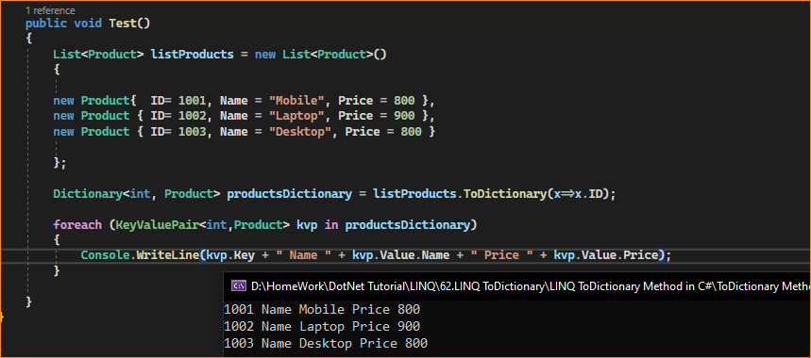

Note: Keep in mind that if there are duplicate keys in the source collection, the **ToDictionary** method will throw an exception. You can handle this situation by providing a custom key selector or using the **ToLookup** method if duplicate keys are expected.

1. Another Overloaded Version of the ToDictionary Method in C#:

The following ToDictionary method Creates a System.Collections.Generic.Dictionary<TKey, TValue> collection from the System.Collections.Generic.IEnumerable<T> according to the specified key selector and element selector.



Parameters:

* source: It is the source System.Collections.Generic.IEnumerable<T> collection from where we need to create a System.Collections.Generic.Dictionary<TKey, TValue>.
* keySelector: A function to extract a key from each element.
* elementSelector: A transform function to produce a result element value from each element.

Type Parameters:

* TSource: The type of elements of source.
* TKey: The type of the key returned by the key Selector.
* TElement: The type of value returned by the element selector.

Returns:

* It returns a System.Collections.Generic.Dictionary<TKey, TValue> that contains values of type TElement selected from the input sequence.

Exceptions:

* It throws System.ArgumentNullException when the source or key selector is null or the key selector function produces a null key.
* It also throws System.ArgumentException when the key selector produces duplicate keys for two elements.

1. Example to Understand the above LINQ ToDictionary Method in C#:

In the following example, we convert List<Product> to a Dictionary. Here, the product ID is the key, and the Product name is its value.

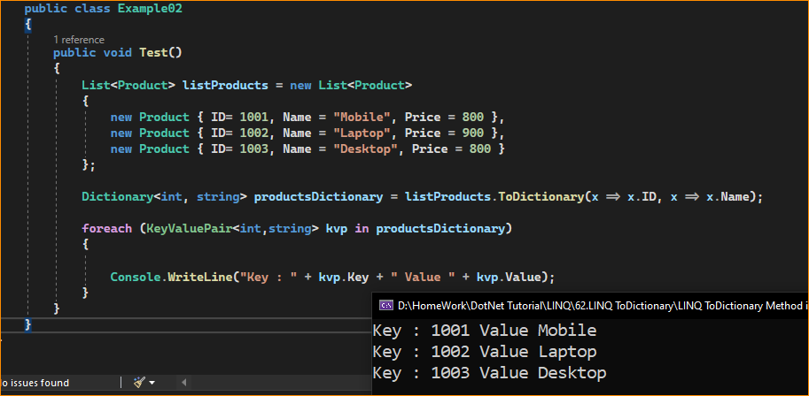

1. What happens when the key is the same for two elements?

In the following example, it throws a System.ArgumentException as there are two products with the same ID (i.e., Products with id 1001), and we are using ID as the key for the dictionary.

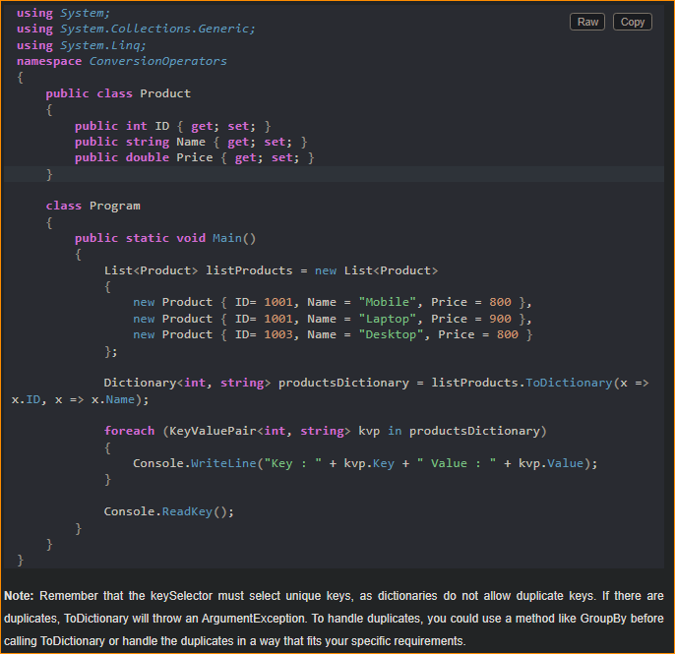

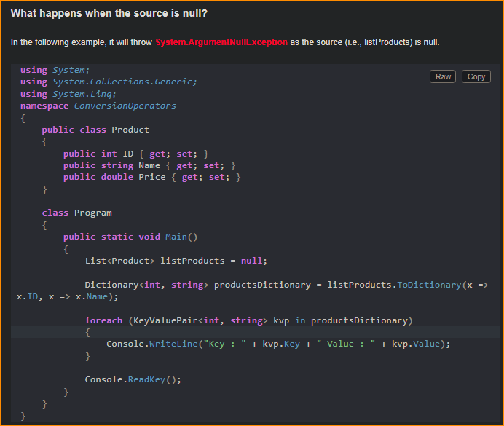



1. When Not to Use LINQ ToDictionary Method in C#?

While the ToDictionary method in C# is a useful tool for converting collections or query results into dictionaries, there are situations where it may not be the best choice. Here are some scenarios in which you might want to avoid using ToDictionary:

* **Duplicate Keys:** If the source collection or query result contains duplicate keys, using ToDictionary will throw an exception. In such cases, consider using the ToLookup method if you need to handle multiple values associated with the same key.
* **Modifying Existing Dictionary:** If you have an existing dictionary that you want to modify, it’s often more efficient to directly add or update entries using the dictionary’s methods (Add, Remove, etc.) rather than creating a new dictionary with ToDictionary. Creating a new dictionary can be less efficient and consumes more memory.
* **Expensive Key or Value Transformations:** If the key or value transformation logic provided to ToDictionary is computationally expensive or involves complex operations, repeatedly using ToDictionary in performance-critical scenarios may result in unnecessary overhead. In such cases, consider precomputing the dictionary or optimizing your code.
* **Deferred Execution Concerns:** Be cautious when using ToDictionary with LINQ queries with deferred execution. The dictionary will be populated when the query is executed, not when ToDictionary is called. If the underlying data source changes between the time you call ToDictionary and the execution of the query, you may get unexpected results.
* **Memory Usage:** Creating a dictionary consumes memory, and if you have a large collection, converting it to a dictionary can lead to increased memory usage. Be mindful of memory constraints, especially in scenarios where memory is limited.
* **Performance Considerations:** In some cases, using a foreach loop or other techniques may be more performant than using LINQ methods like ToDictionary, especially for simple data transformations or when working with large datasets.
* **Simplicity:** If you don’t need the key-value structure provided by a dictionary and are just iterating over the data or performing other operations, using ToDictionary might introduce unnecessary complexity to your code.

So, the ToDictionary method is useful whenever you need to convert data from a collection or query result into a key-value data structure for efficient lookups, grouping, or indexing purposes. It’s a powerful tool in LINQ that can simplify many data manipulation tasks in C#.